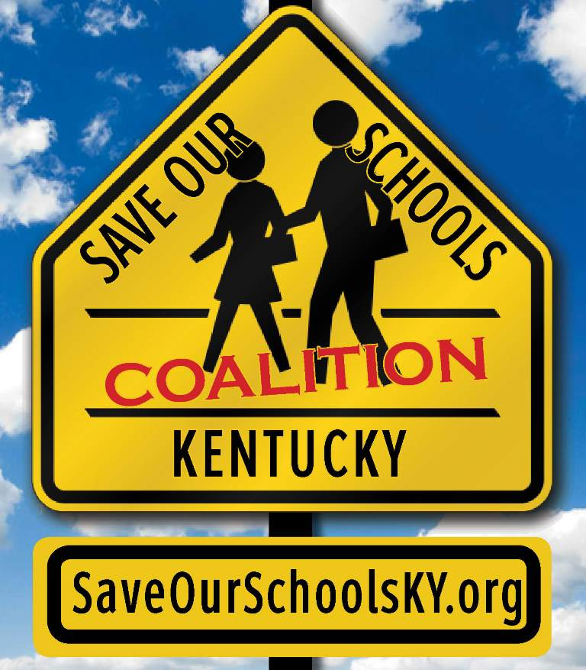
Invitation to Join the

Save Our Schools KY Coalition

The SOSKY coalition opposes charter schools because they are a threat to public education in Kentucky. Where charter schools are allowed, public schools suffer, taxpayers are swindled, and students are worse off. And we have 25 years of evidence to prove it.
Dear Colleagues:
As an organization that understands the importance of free, accessible quality public education for all, you are invited to join a coalition dedicated to opposing devastating charter school legislation in the state of Kentucky. Two bills have already been filed, which, if implemented, pose numerous problems to public schools and students across the state. We must act quickly and efficiently if we hope to make an impact.
Coalition members are asked to:
- host panels or screenings to carry a share of the work in “educating, informing and mobilizing,”
- share information from the coalition with their members on a regular basis,
- engage their members in “action alerts” to contact legislators when appropriate,
- help pitch in for some of the costs and manpower incurred in maintaining the coalition, if possible,
- assign a coalition delegate to participate in any discussions so that we can move quickly as an organized force that is inclusive of all members’ objectives and concerns.
Since the current legislative session is already underway, we are operating on a tight timeline. Please present this invitation at your next board meeting to confirm your organization’s ability to participate. If you are not the appropriate individual within your organization for this activity, please forward this on as quickly as possible.
We are reaching out to the organizational representatives we have been able to identify. If you know of others who you think would also like to join us, please have them contact us.
On behalf of the undersigned preparers of this Invitation, we want to thank you for your continued efforts and support. In order to expedite the Coalition response, please return e-mail the form on reverse.
We sincerely hope you will join with us in this vital effort of protecting Kentucky public schools from destructive charter school legislation.
Most cordially,
Gay Adelmann
SOSKY Co-Founder
(502) 565-8397
moderator@saveourschoolsky.org

Save Our Schools KY Coalition

Response Letter

The SOSKY coalition opposes charter schools because they are a threat to public education in Kentucky. Where charter schools are allowed, public schools suffer, taxpayers are swindled, and students are worse off. And we have 25 years of evidence to prove it.
Name of Organization __________________________________________________
Address_______________________________________________________ _____________________________________________________________
Contact Person ___________________________________Title__________________________________
E-mail_________________________________________ Phone________________________________
Please select all that apply:
1. ____ Yes, our organization supports the above position statement and would like to join the Save Our Schools Kentucky Coalition. We will participate in the activities outlined in the invitation to the best of our ability. Our name and logo can be published in press releases, materials and on the website.
2. ____ Our organization will publish a letter to our legislators denouncing proposed charter school legislation.
3. ____ Our organization will submit an opinion letter to the local paper denouncing proposed charter school legislation.
4. ____ Our organization will contribute financial support to the SOSKY coalition in the amount of $_____________ to assist with marketing, communication and logistical efforts.
5. ____ We are interested but our organization needs more information before making a commitment.
6. ____ No, we are not interested in joining the Coalition at this time. Please provide brief rationale: ________________________________________________________________________________________________________________________________________________

